The formation of the Adirondacks and their role in the ecosystem

Introduction

The Adirondacks rocks are known to be the most ancient rocks known anywhere on the earth's surface and they range in age between ca. 1350-1000 million years old compared to the White mountains that are only 124-100 million years ago. It dates to the Precambrian period where it is recorded that the first multicellular organisms evolved, and the sexual division developed, and it is also the period that is marked by different layers of sedimentary minerals.

Compressed over a period of million years, these rocks contain fossils remains of plants and animals buried when the sediments were formed. The Adirondacks contain mostly metamorphic and igneous, over one billion years ago, but were once covered by ocean sediment. It is believed that there were sheets of sand, mud, and calcareous mud, that were deposited on the floor of somebody of water. These rocks are gneisses and schists as well as some coarsely crystalline limestone.

Glacial geology

Alpine glaciers or mountain glaciers are sheets of ice that are formed on the summits and follow a downward motion due to gravity. The small alpine glaciers were forming in the Adirondack Mountains. These alpine glaciers carved the upper slopes of the mountains for thousands of years and the Adirondacks experienced a momentous change in the climatic conditions. The Labrador ice sheet was a major ice sheet that covered large parts of North America during glacial periods over the last ~2.6 million years. And about 20,000 years ago, the Earth started to warm up and the Labrador ice sheet started to melt.

From the north or northeast east region, the Labrador ice sheet advanced itself to the Adirondacks. The Labrador ice sheet turned south along the west side of the Adirondacks and entered the Mohawk valley from the west. The ice increased in thickness until it covered the area for about 2.6 million years. When the ice disappeared, it modified the topography by its glacial wear and glacial deposit. Some of the landscape changes were the smoothening of the ridge slopes, summits rounded, valleys clogged with deposit due to the downward erosion of lakes.

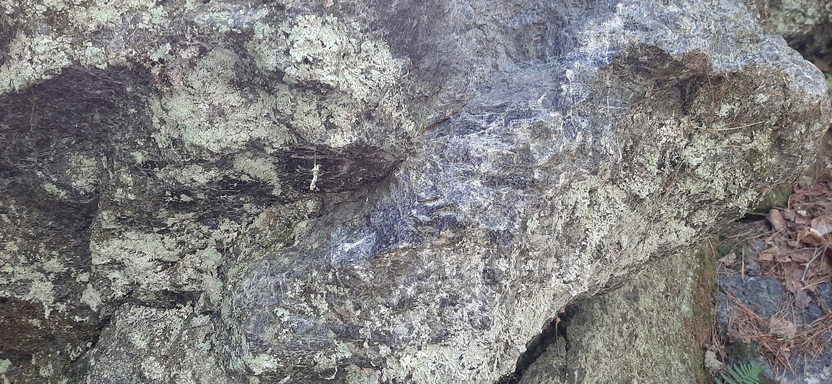

Figure 1: shows a piece of rock from an erratic glacial feature, taken in the charcoal kiln quarry or the rock-climbing boulder in the Adirondacks. Minerals that are visible are mica, quartz, and felsic andesine. These rocks are classified as metamorphic orthopyroxene rocks which lie within the mafic family because they are a darker color because of their high magnesium or iron content. (Giji)

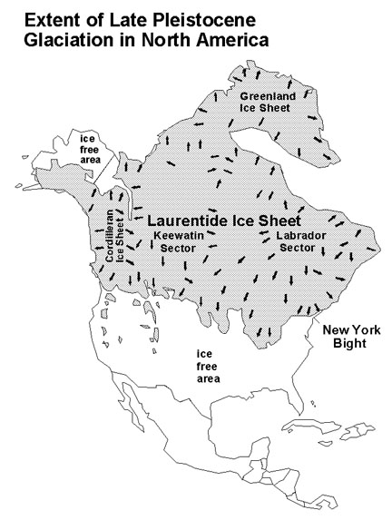

Figure 2: Map showing the expansion of the Laurentine ice sheet. The Labrador ice sheet is a small sect of the Laurentine ice sheet. This happened during the late Pleistocene glaciation period. (Maps from USGS, modified after Pielou, 1991)

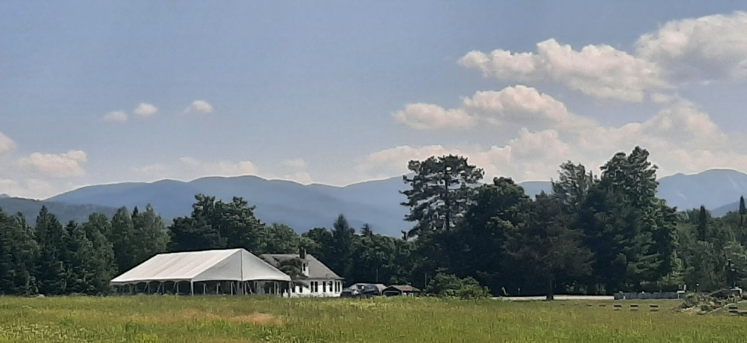

Figure 3: A picture of some of the 46 high peaks of the Adirondacks. (Giji)

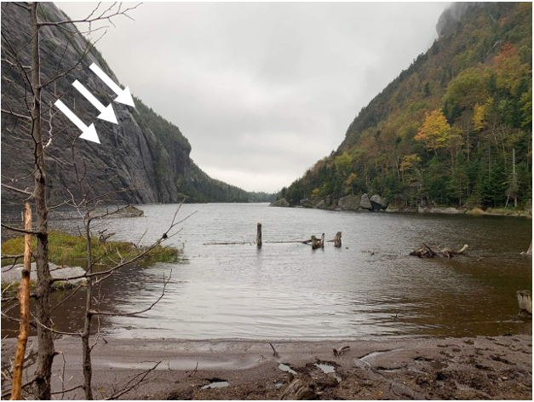

Figure 4: A picture from Jake shows how the glacier had cut through the mountains. On the bedrock surface you can see striations that were made by rocks frozen into basal ice scraping over the bedrock. There are huge boulders on the edge of the lake and the deposition of till. (Atkinson)

Glacial features

When ice erodes the land surface it carries the eroded rocks and soil debris to new places, and different glacial features are formed through this process. When the ice advanced towards the Adirondacks soil, the rock was scraped from the land and embedded in the ice. This scratched and smoothened the Earth’s surface and broke down boulders into pebbles. When the ice melted, a feature called erratic was deposited throughout the Adirondacks. Glacial erratics are rocks or boulders that were transported through glacier movement and left behind after the glacier melted.

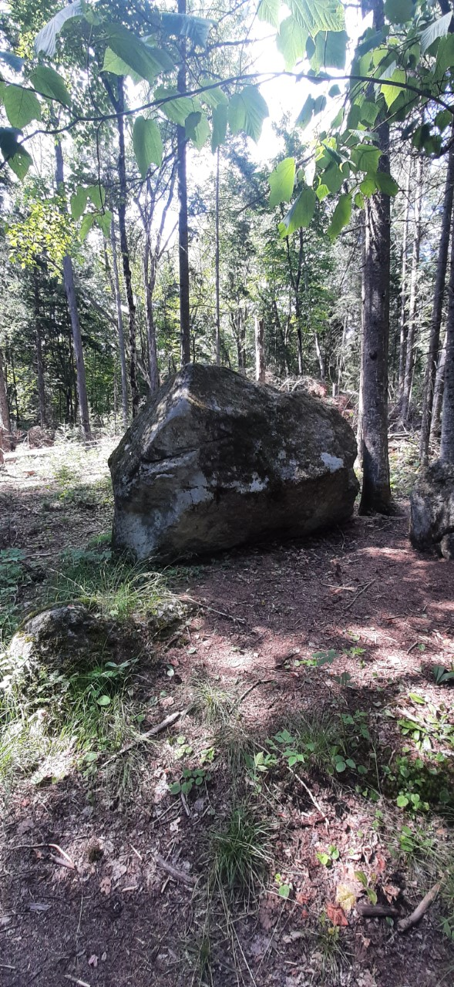

Figure 5: An erratic found in the beginning of the trails in the VIC. (Giji)

An important glacial feature that is formed are the moraines. Moraines are landforms that consist of glacial till that was deposited by glacier ice. The Adirondacks have little moraine material since most of it has been stratified by water. You could find local moraines within the brook valleys. There are remnants of morainal ridges around the walls of the valley.

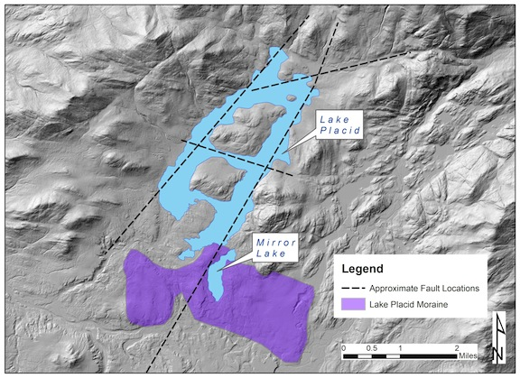

Figure 5: This shows the moraine dam on Lake Placid. It also shows the fault locations. Lake Placid is a rift valley lake that was formed because of movement on faults within a rift zone. You could also see the Lake Placid moraine nearby which means there was still movement of sediment after the lake was formed. (Bedrock and Surficial Geology Maps of New York, Adirondack Sheet)

Another well-known glacial feature is the eskers. Eskers, which are a long, narrow ridge of gravel and coarse sand, are quite uncommon. But they are formed when glacier ice water is flowing slowly and collects and flows through a network of tunnels. This water has a large quantity of debris which is composed of coarse-grained gravel which is stratified and sorted.

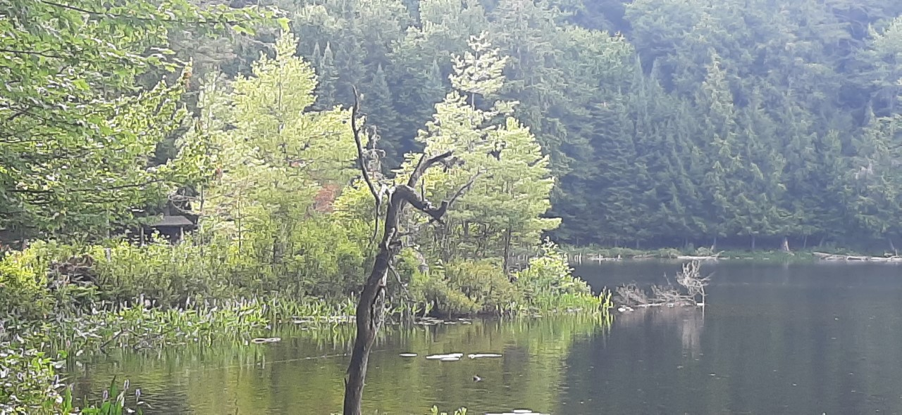

Figure 6: A glacial eskers located at Black Pond Trail in the VIC. (Giji)

Stratigraphy and structural geology

The Grenville orogeny was formed from the collision between Laurentia and one or more continental blocks. It is a long-lived Mesoproterozoic mountain-building event, and its belt expands all the way to a massive portion of the North American continent. In other words, the margin sediments were caught in between the colliding continents and was thrust up towards North America.

The formation of the Adirondack started with the movement of the earth's tectonic plates. So, all around the Adirondack rocks there are Grenville sediments that are interbedded with other rocks, most likely igneous. The rocks share a SW-NE structural grain and a complicated tectonic history. But it is quite like the Appalachian Mountains because the Grenville Orogeny occurred over a 250-million-year period. The Adirondack mountains form a small portion of the Grenville Province.

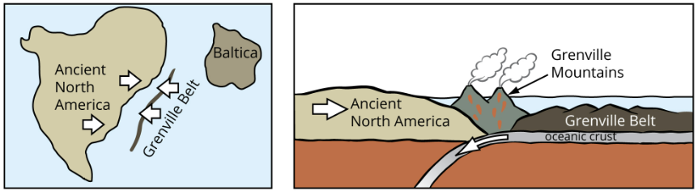

Figure 6: shows the formation of the Grenville mountains through the collision of the North America plate and Grenville Belt. (J. Houghton)

The structural geology of the Grenville rocks is mostly limestone, which is a sedimentary rock composed of calcium carbonate (calcite). Most of the Grenville rocks you find are a mixture of red, gray, and black gneisses which have the composition of igneous rocks, granites, syenites, diorites and gabbros that have become metamorphized. Currently you can see evidence of the Grenville Orogeny in the Adirondacks, the rocks have been found in numerous long, narrow belts around the borders of the Adirondacks.

The stratigraphy sequence of the Adirondacks involves multiple folding, metamorphism, and intrusive activity. The mountains have experienced several phases of deformation, folding, magmatism and metamorphism. There was an unroofing that was caused by regional uplift which gave the Adirondacks its domal shape.

Fun Fact: - Somewhere in the Adirondacks where there is a low-velocity zone, you can find the remnants of the passage of the Laurentian plate over the Great Meteor hotspot.

Bedrock/surficial geology maps

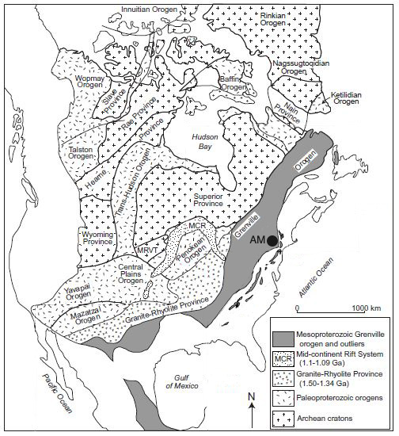

Figure 7: Map of North America showing the Grenville orogen and older geologic provinces. (Tollo 2004)

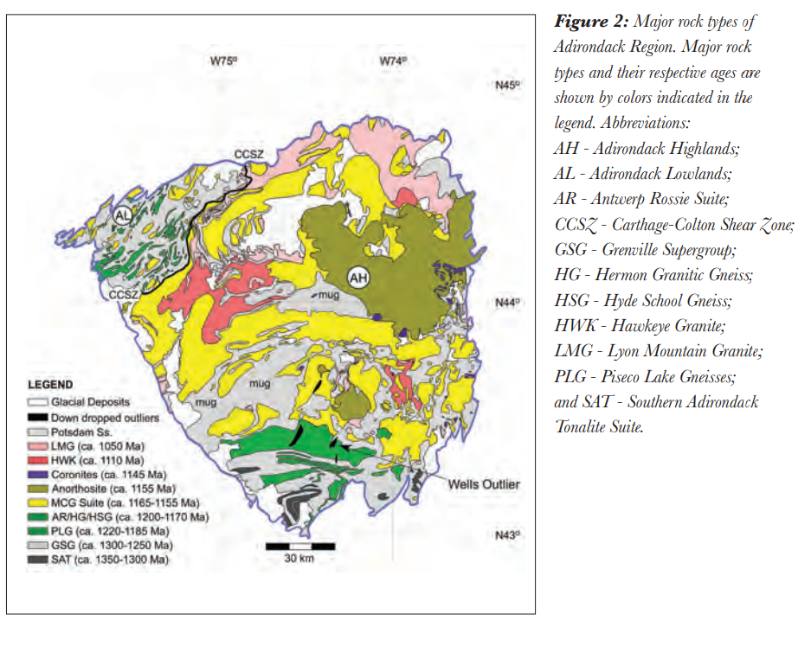

Figure 8: Bedrock geology of the Adirondack region. (CHIARENZELLI and SELLECK, 22)

The rocks in the Adirondack region are mostly metamorphic and igneous rocks. The most common igneous rock is granite which contains minerals such as silica, potassium, sodium, quartz, and alkali feldspars. There are also younger Paleozoic rocks such as sandstones, limestones, and shales. But you find these in fault-bounded outliers within the Adirondack or around the Adirondack margins.

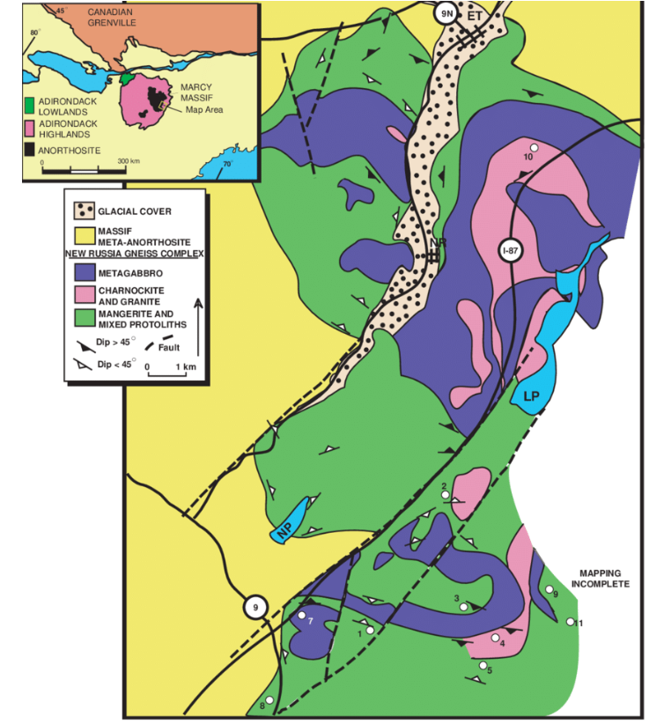

Figures 9: This is the surficial geologic map of a town in the NE Adirondacks Highlands. There is a great quantity of anorthosite which is a type of intrusive igneous rock composed of calcium-rich plagioclase feldspar. (Alcock)

Soil formation at the Adirondacks

Glaciers are known to ground up bedrock and deposit the fragments in mounds called moraines and that form new soils. The two main erosion process boulders go through are plucking and abrasion, where the rock and other sediment are picked up by a glacier and as the glacier moves, it gets scraped with the underlying rock. The same is with the Adirondacks, where most of the region is covered by an acidic, sandy, low-fertility soil called a Spodosol, that has developed during a sandy drift. (April, Keller, and Hluchy, 147 pg.) They have an overlying dense till soil. According to the USDA the Adirondack soils are, “well drained Potsdam, Berkshire and Becket soils and the moderately well drained Crary, Skerry and Sunapee soils that are on higher topographic positions.” These different soils series are what provide the nutrients plants need to grow in the Adirondacks.

Soils are usually formed not only through the breaking down of rocks, but plants and animals contribute too. Plant and animal material are decomposed through the involvement of micro-organisms. And the by-products of this process form organic acids that are then washed into the ground thus making the soil acidic. Whereas organic matter comes together, and they form the layers in the soils’ topography thus giving the dark or red colored soil horizons. Organic matter is important because it provides granulation, good tilth, and water infiltration, and increases porosity.

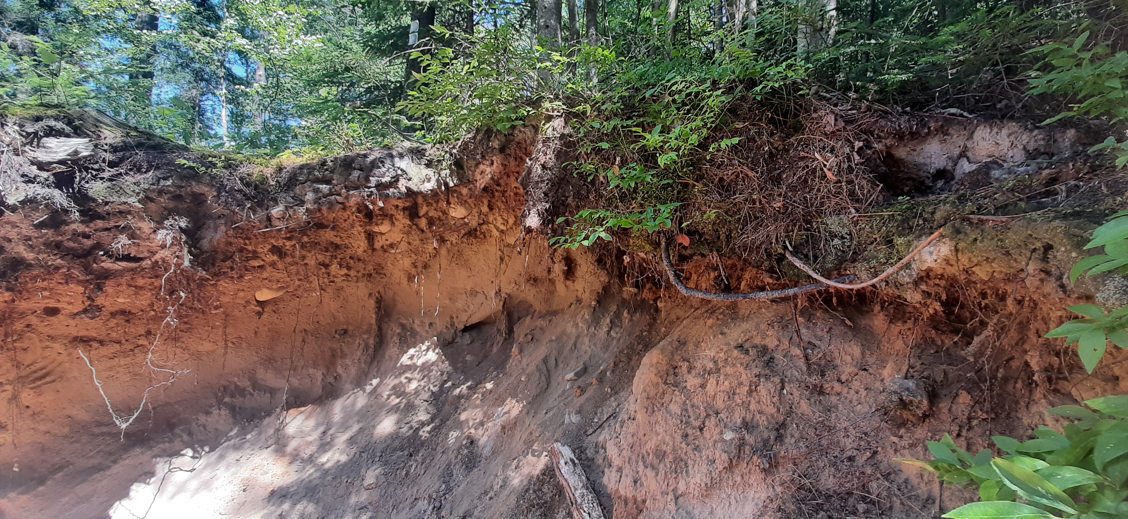

Figure 10: shows the soil's horizon from Shingle Mill falls in the VIC. It looks like the parent material is glacial outwash and it is excessively well drained. (Giji, 2022)



This soil topography was created by glacial outwash plains where sand and gravel are carried by running water from the melting ice of a glacier. Spodosol is the soil order, and they are known to develop distinctive color horizons since they are naturally acidic, but they contain the essential elements for a healthy forest to thrive such as wildlife, micro-organisms and vegetation.

Adirondack habitats

The Adirondacks mountains lie in the transition zone between the eastern deciduous and boreal forest biomes. (SUNY College of Environmental Science and Forestry, 2022) The climatic conditions provide a home for a variety of forests within the Adirondacks. Some mixed wood forests have a mixture of conifers trees and hardwoods, this strongly depends on the soil fertility. The soil in mixed wood forests is soil that had been derived from outwash, so they are filled with sand and gravel that were deposited by glacial rivers, but they are rarely fertile. Conifer trees have woody trunks, stems and their leaves often look like needles. They are also known to remain green in all seasons because the leaves live for several years. But this makes it a perfect habitat for certain bird species such as the Black-capped Chickadee and the Blue Jay and some birds that migrate in the summer like the Hermit Thrush and the Ovenbird.

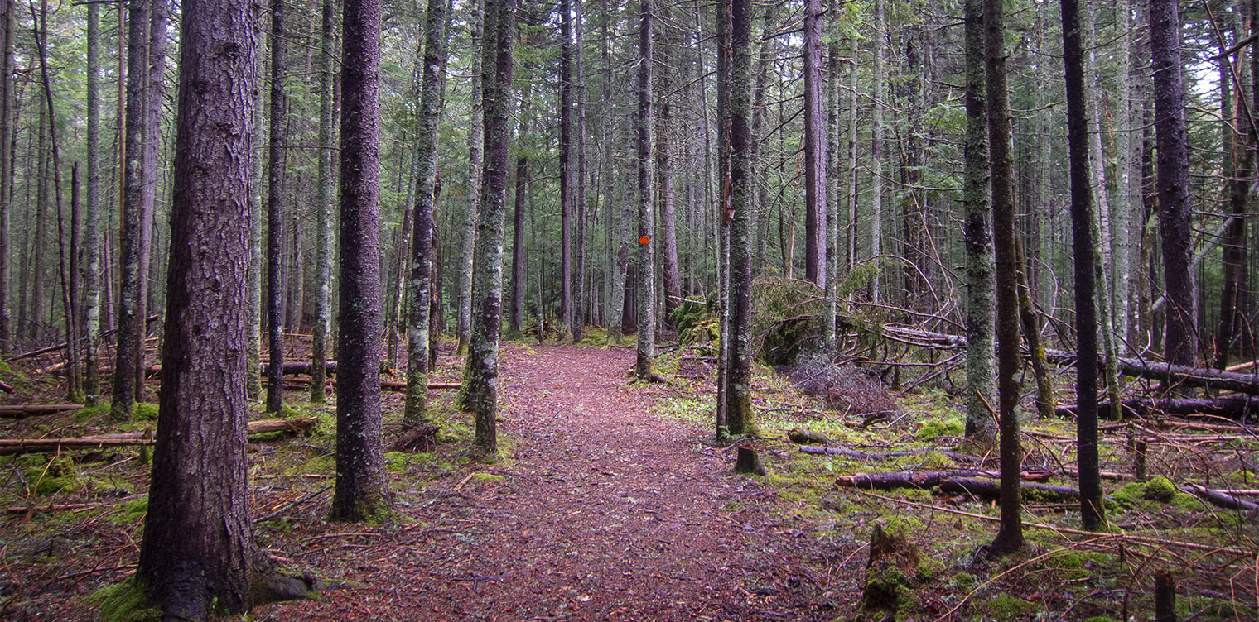

Figure 11: A picture of conifer trees at the Paul Smith's College VIC. (20 May 2018)

Towards the north end of Adirondacks, we have the Northern Hardwood Forests. It is home to the region's best soil and the plants that grow their flourish because of the fertile soil that is mostly made up of glacial till. But this means that only the shade-tolerant seedlings can grow to maturity. Two of the dominant species are the Sugar Maple and American Beech as they are known to tolerate more shade than the hardwood trees and can easily grow on the deep, fertile, and well-drained soil.

One of the most beautiful aspects of a forest is its ecological succession. There is a constant change from either nature or through human hands where it could be because of a catastrophic weather event or logging. Exploring with Paul Smith’s professor, Justin Waskiewicz, I got to witness various forest types that looked untouched by human hands but in fact were recovering forests. Most of the Adirondacks Forest had been either burned down or cut down for logging. But that gave way for other tree species that were not able to thrive in a shady environment. And eventually, we get to witness a more stable forest with a mixture of lasting and shade-tolerable trees a more homogenous result.

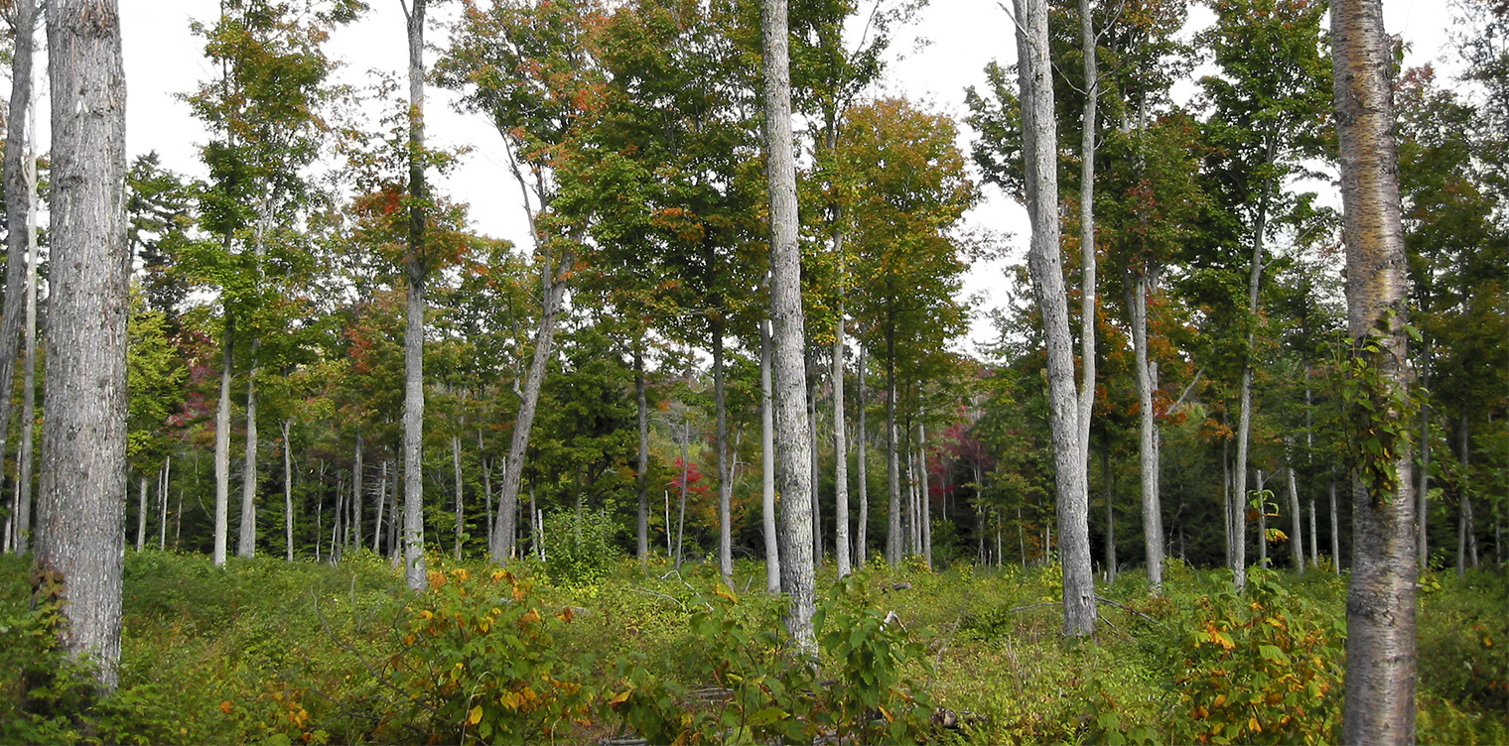

Figure 13: A picture of the ecological forest succession at the Paul Smith's College VIC. (20 September 2004)

Conclusion

The Adirondacks mountains were formed through the vertical uplifting and collision of plate boundaries and the exposed rocks in the surface range in age from 1350-1000 million years old. These metamorphic and igneous rocks are gneisses and schists as well as some coarsely crystalline limestone. We know that the alpine glaciers have carved the upper slopes of the mountains for thousands of years but during the glacial period they have smoothened the slopes and the summits of the mountains. But they have created features such as moraines, eskers, cirques. The Adirondacks are known for their glacial geology and landscapes. This formation has created a great habitat for wetlands, lakes, and many other forests. Through the regeneration of forests, a climax ecosystem was created and is now home to a diverse number of plant and animal species.

Citations:

“Get Precambrian Time Information and Prehistoric Facts.” *Science*, National Geographic, 3 May 2021, <https://www.nationalgeographic.com/science/article/precambrian-time>.

Adirondackcouncil.org. (n.d.). *The Adirondacks Rock! the beginning*. Adirondack Council. Retrieved July 26, 2022, from <https://www.adirondackcouncil.org/page/blog-139/news/the-adirondacks-rock-part-1-the-beginning-1070.html>

*Ice age New York*. New York Nature. (2021, August 11). Retrieved July 26, 2022, from <https://www.newyorknature.us/ice-age-new-york/>

*National Snow and Ice Data Center*. Glacier Landforms: Erratics | National Snow and Ice Data Center. (n.d.). Retrieved July 26, 2022, from <https://nsidc.org/cryosphere/glaciers/gallery/erratics.html>

Misachi, J. (2017, April 25). *Mountain and glacial landforms: What* *is an Esker?* WorldAtlas. Retrieved July 26, 2022, from <https://www.worldatlas.com/articles/mountain-and-glacial-landforms-what-is-an-esker.html>

Lake Placid News. (2021, May 27). *Ausable water wise: Origins of lake placid and mirror lake*. News, Sports, Jobs - Lake Placid News. Retrieved July 26, 2022, from <https://www.lakeplacidnews.com/opinion/columns/2021/05/27/ausable-water-wise-origins-of-lake-placid-and-mirror-lake/>

*Grenvillian orogeny*. Grenvillian Orogeny - an overview | ScienceDirect Topics. (n.d.). Retrieved July 26, 2022, from <https://www.sciencedirect.com/topics/earth-and-planetary-sciences/grenvillian-orogeny>

*Geology of the Adirondack Mountains*. USGG-Adirondacks-Page 1. (n.d.). Retrieved July 26, 2022, from <https://usgeologymorphology.com/adirondacks-p1.html>

*Geologic history of the Northeastern United States*. Earth@Home. (2022, April 27). Retrieved July 26, 2022, from <https://earthathome.org/hoe/ne/geologic-history/>

*Adirondack Series*. Official Series Description - ADIRONDACK Series. (n.d.). Retrieved July 26, 2022, from <https://soilseries.sc.egov.usda.gov/OSD_Docs/A/ADIRONDACK.html>

Forests of Adirondack Park - Let's Learn Ecology! - hamilton college. (n.d.). Retrieved July 26, 2022, from <https://courses.hamilton.edu/forests-of-the-adirondack-park/lets-learn-ecology>

Broderson, W. D. (2003). *From the surface down: An introduction to soil surveys for agronomic use*. U.S. Dept. of Agriculture, Natural Resources Conservation Service, National Employee Development Staff.

Chiarenzelli, Jeffrey R., and Bruce W. Selleck. "Bedrock geology of the Adirondack Region." *Adirondack Journal of Environmental Studies* 21.1 (2016): 5.

Cushing, Henry Platt. *Geology of the northern Adirondack region*. No. 95. New York State Education Department, 1905.

ALLING, HAROLD L. "Glacial lakes and other glacial features of the central Adirondacks." *Bulletin of the Geological Society of America* 27.1 (1916): 645-672.

Adirondack Habitats. (n.d.). Retrieved July 27, 2022, from <https://wildadirondacks.org/adirondack-habitats.html>

Jerry Smith, Janella Cruz, Rebecca Fox Adirondack Soils Tour. USDA (n.d.). Retrieved July 26, 2022 from [Adirondack Soils Tour.pdf](https://livepaulsmiths-my.sharepoint.com/:b:/r/personal/mjohnson1001_paulsmiths_edu/Documents/Geology/Adirondack%20Soils%20Tour.pdf?csf=1&web=1&e=OKVZy9)